

Jax Francis
Professor Kayl
CS-340 Client/Server Development
01/24/2026

Module Three Assignment
CRUD In MongoDB

- In Codio, open the terminal window to access the Linux shell. Upload the Austin Animal Center (AAC) Outcomes data set into MongoDB by importing a CSV file using the appropriate MongoDB import tool. Use the database name “aac” and collection name “animals.” Complete the import using the mongoimport tool, and take screenshots of both the import command and its execution.
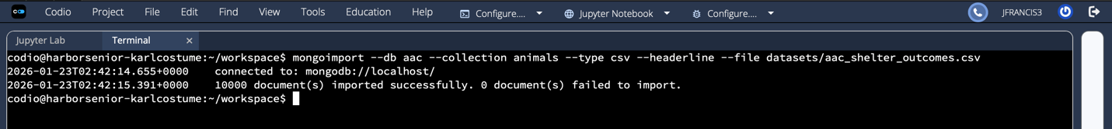

- After importing your data set, open the mongo shell. Create a simple index on the key “breed.” Show an example query using this index, and use the explain function to verify that the index will be used. Take screenshots of your example query.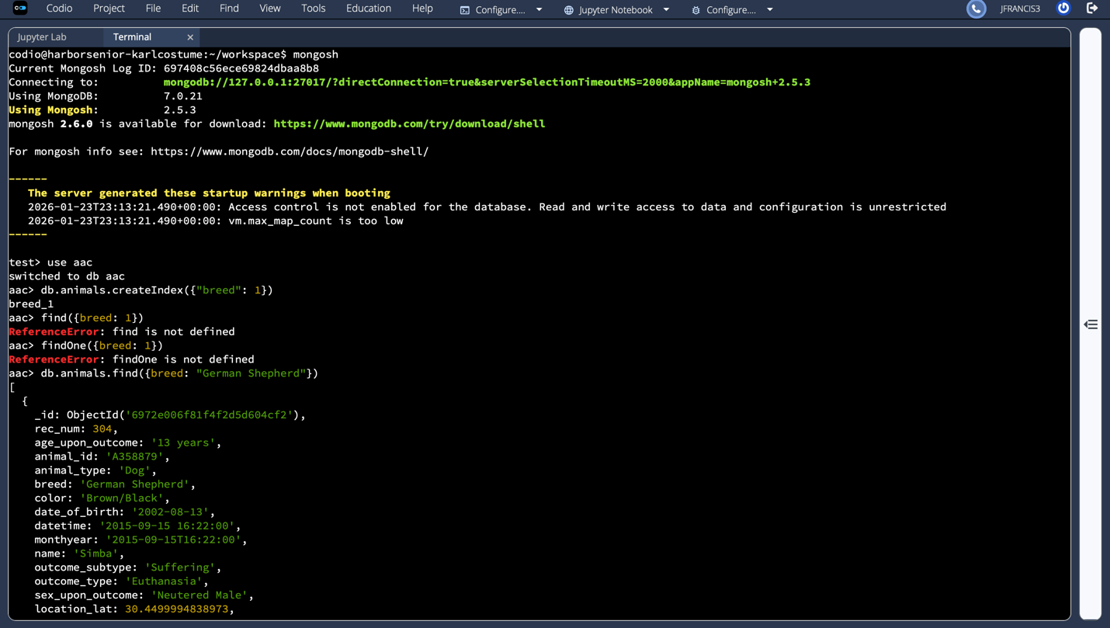
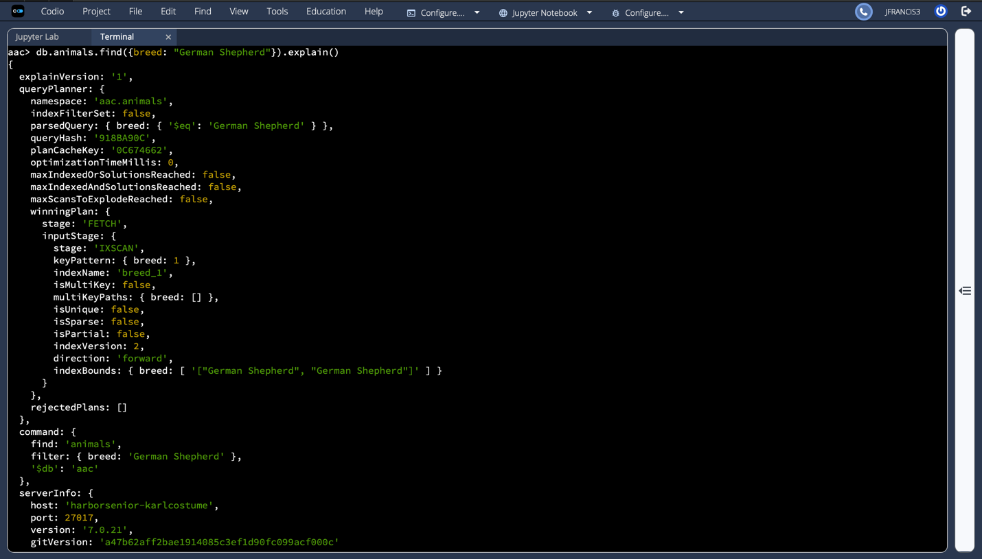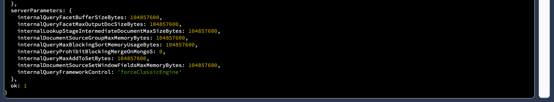
3. Create a compound index that will improve the performance of queries looking for breeds that have an “outcome_type” of “Transfer.” Show an example query using this compound index, and use the explain function to confirm the index will be used. Take screenshots of your example query.
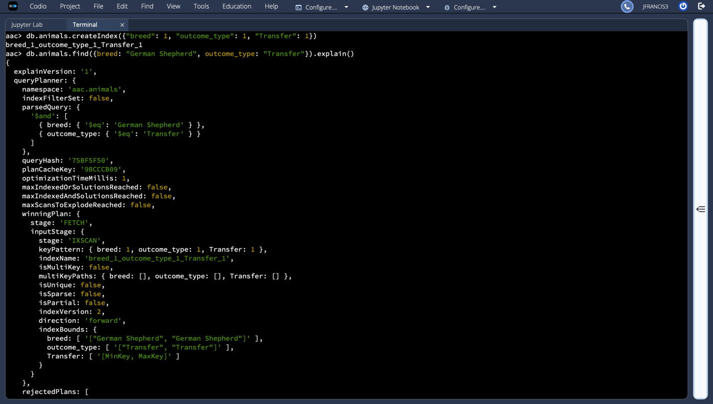
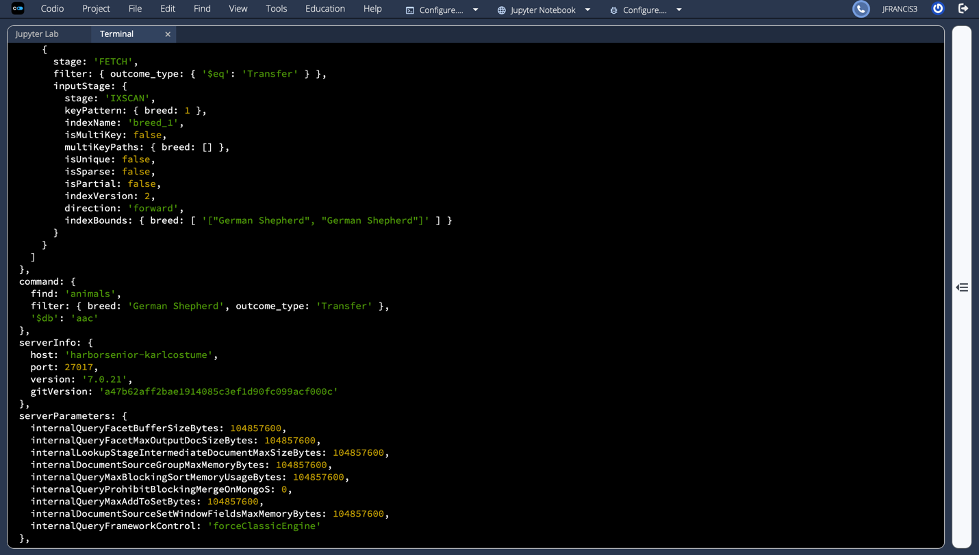

Part II: User Authentication

- Create a new user account called “aacuser” with read and write access to the database “aac” in the default “admin” authentication database using the mongo shell.
Note: You will create your user in the admin database, even though it will only have a role in the aac database.

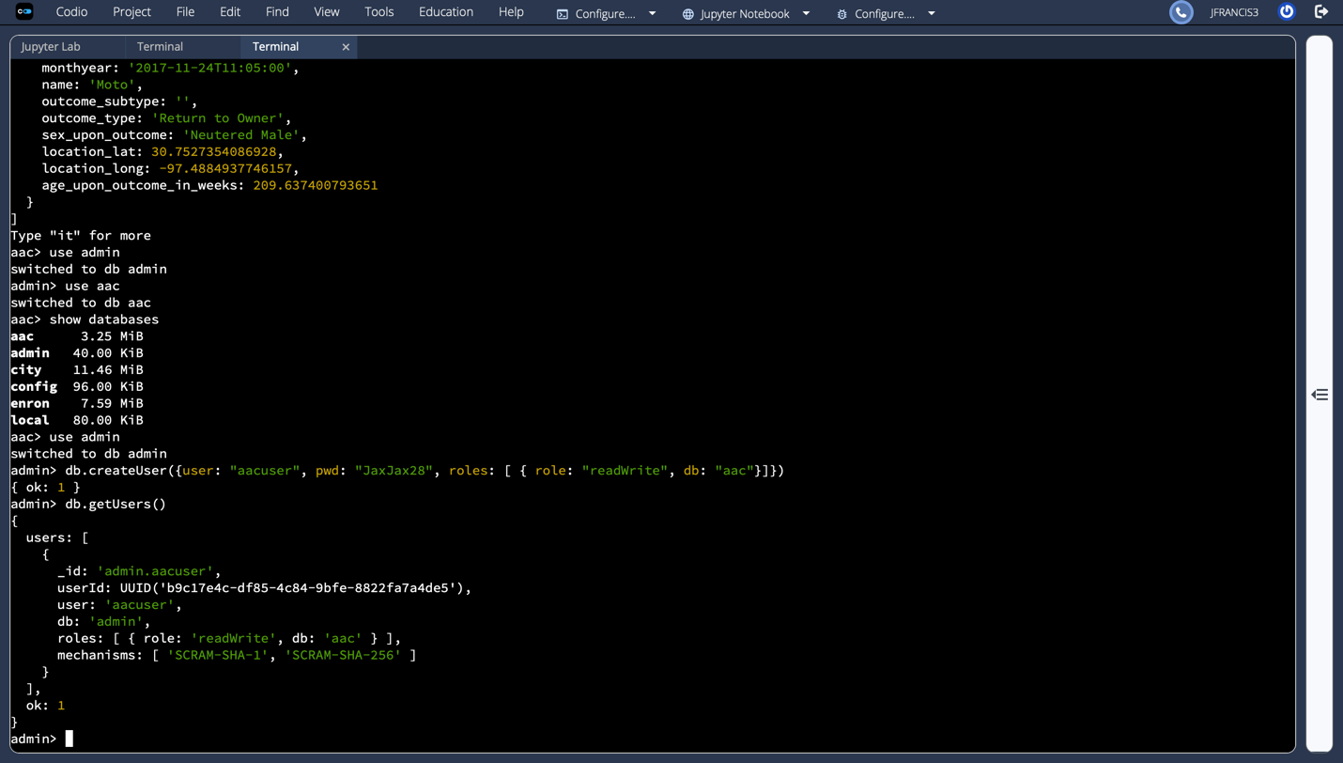

- Take a screenshot of your login process to MongoDB using the mongo shell. Be sure you can access MongoDB and list the databases using the aacuser account. This task will verify that your aacuser account is working. You should be able to include the login command and connection information in one screenshot.
When you have successfully attached to your MongoDB instance with mongosh, use the steps to authenticate after connection to log in as the aacuser, then use the following command to verify that you have connected as the specific user: